 | PERSONAL DETAILS  Gender: Male  Nationality: South African
 | PROFESSIONAL SKILLS
 | QUALIFICATIONS AND TRAINING
COMPUTER SKILLS
- Microsoft Office

 | PROFESSIONAL MEMBERSHIP
 | LANGUAGES  English

Name of Candidate
CURRICULUM VITAE

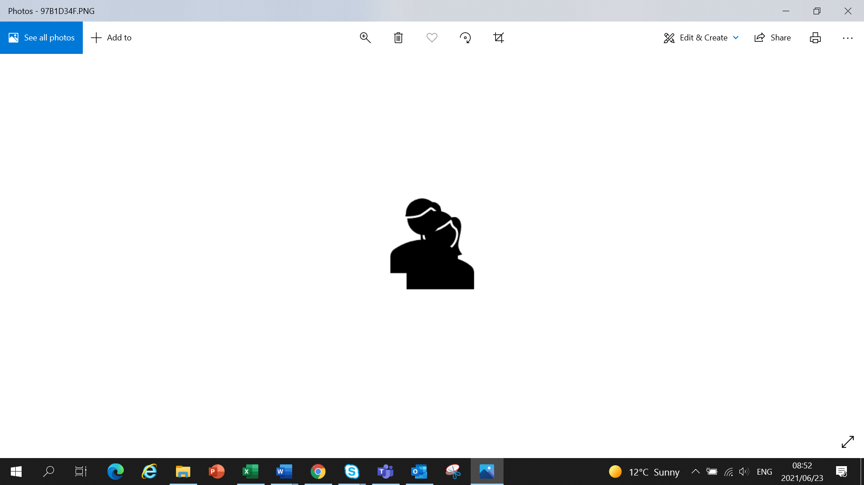

PROFILE

EXPERIENCE

Company: Name
Position: Job Title
Period: April 2025 - Current

Scope of work:

Company: Name
Position: Job Title
Period: April 2023 - March 2025

Scope of work:

